**Standard Deviation**

The Standard Deviation is a measure of how spread out numbers are.

Its symbol is **σ** (the greek letter sigma)

The formula is easy: it is the **square root** of the **Variance.** So now you ask, "What is the Variance?"

**Variance**

The Variance is defined as:

The average of the **squared** differences from the Mean.

To calculate the variance follow these steps:

* Work out the [Mean](http://www.mathsisfun.com/mean.html) (the simple average of the numbers)
* Then for each number: subtract the Mean and square the result (the *squared difference*).
* Then work out the average of those squared differences. ([Why Square?](http://www.mathsisfun.com/data/standard-deviation.html#WhySquare))

**Example**

You and your friends have just measured the heights of your dogs (in millimeters):  
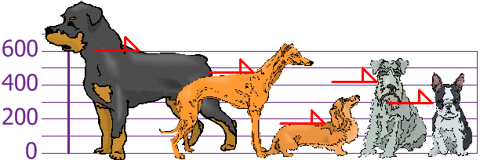

The heights (at the shoulders) are: 600mm, 470mm, 170mm, 430mm and 300mm.

Find out the Mean, the Variance, and the Standard Deviation.

Your first step is to find the Mean:

**Answer:**

Mean  =  (*600 + 470 + 170 + 430 + 300) /* **5**  =  *1970 /* **5**  =  394

so the mean (average) height is 394 mm. Let's plot this on the chart:

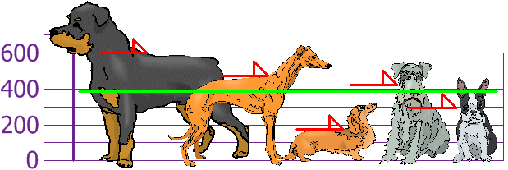

Now we calculate each dog's difference from the Mean:

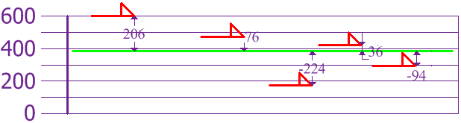

To calculate the Variance, take each difference, square it, and then average the result:

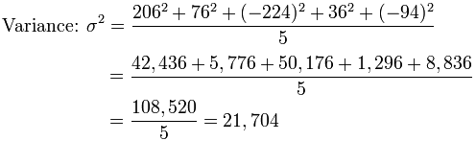

So the Variance is **21,704**

And the Standard Deviation is just the square root of Variance, so:

|  |  |
| --- | --- |
| *Standard Deviation* | |
|  |  |
| **σ** | **= √21,704** |
|  | **= 147.32...** |
|  | = **147** *(to the nearest mm)* |

And the good thing about the Standard Deviation is that it is useful. Now we can show which heights are within one Standard Deviation (147mm) of the Mean:  
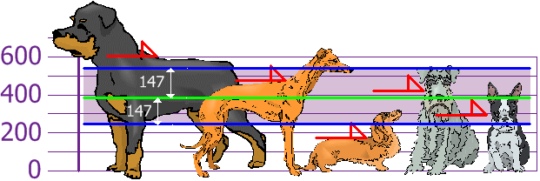

So, using the Standard Deviation we have a "standard" way of knowing what is normal, and what is extra large or extra small.

Rottweilers **are** tall dogs. And Dachshunds **are** a bit short ... but don't tell them!

